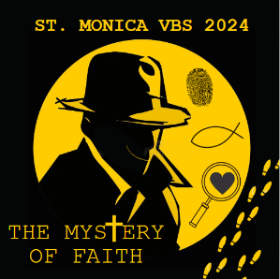
St. Monica Vacation Bible School
RETURN FORM BY JULY 26
to jessica.tette@dor.org
or mail to
St. Monica Church
34 Monica St. Rochester
NY 14619

August 12-16, 2024
Ages 4 & up • 8:45 AM until Noon (lunch included)
Questions: email jessica.tette@dor.org
If you or your child have any symptoms of COVID-19,
please test before attending VBS.

 | Name | Gender | Grade  Entering | Date of Birth | Special Needs/Allergies*  see other side | School attending | T-shirt size
Child 1
Child 2
Child 3
Child 4
T-SHIRT SIZES:
Youth S, M, L, XL
Adult S, M, L, XL, 2XL, 3XL

Parent/Guardian Name: ___________________________________________

Phone: _______________________ Email: _________________________________________

Address: __________________________________________ Zip: _______________

Emergency Contact (someone other than parent/guardian): _______________________________________

Emergency Contact Phone: ________________________________

Are you registered members of St. Monica Church? Y N Are you interested in volunteering for VBS? Y N

OVER
-------------------------------------------------------------------------------------------------------
Save the dates!
Cut this out and post on your fridge or calendar!
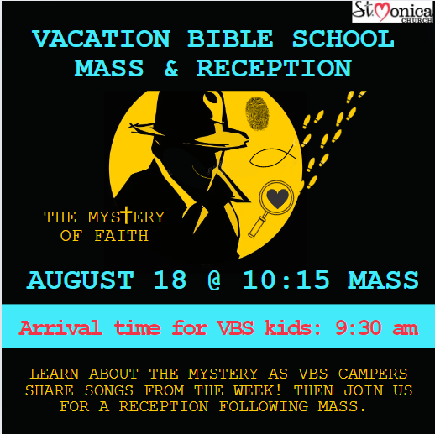
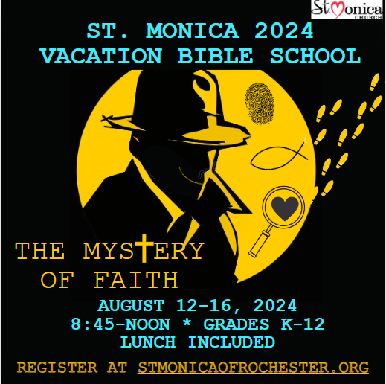
831 Genesee St.

*Details about special needs/allergies:

Health Insurance Company name: ____________________________________________

Primary Care Physician: ________________________________________ Physician Phone: _____________________________

LIABILITY RELEASE: I understand that reasonable precautions will be taken to safeguard the health and wellbeing of participants in St. Monica VBS activities and that I will be notified as soon as possible in the event of an emergency. In the case of sickness or an accident, I authorize and consent the VBS Team or other volunteer or church staff member to obtain medical care from a licensed physician, hospital, or medical clinic for my child in the event that myself or other legal guardian cannot be reached. I hereby do release and forever hold harmless this Diocese of Rochester and St. Monica Church of Rochester from all manners of actions, claims, which I or the child named above shall or may have for any reason arising during my and my child’s attendance of VBS events.
Parent/Guardian Signature/Date: _________________________________________________

MEDIA RELEASE: I consent to allowing my and my child’s image and to be recorded, either by photograph or video, to be used for promotional or publicity purposed for St. Monica Church/Emmanuel Church of the Deaf. Please note that St. Monica Church will not associate any identifying information with the photographs or videos without contacting the parent/guardian. Parent/Guardian Signature/Date: _________________________________________________

VBS at St. Monica is funded by the generosity of the Bedford family fund and so many of our St. Monica parishioners. Donations are always welcome.

Please return VBS registration to Jessica at Jessica.tette@dor.org or mail to the church office by July 26th.
OVER
Peace! Jessica Tette, Youth Faith Formation at St. Monica Church

